  Unified Intelligence Framework – phase 2  1.0 | High Level summary  The focus in Phase 2 of the Unified Intelligence Framework is on aligning Workfront Content IDs throughout AEM platforms while securing IDs for touchpoint attribution and boosting lead improvement via Workfront Data  Connected Strategy & Intelligence Team  Digital Marketing Manager

Revision History
Date | Version | Description | Author
27/04/2026 | 1 | Draft Copy | Amanda Pattenden

Table of Contents

1. Introduction 3
Problem Statement – Why? 3
Vision – What? 3
Benefit Summary – Who? 3
2. Scope and Limitations 4
Assumptions 4
Dependencies 4
Success Metrics 4
3. Business Process 5
Tagging & Tracking – Current vs. Future State 5
Phase 2 – Process Flow 5
4. Stakeholder Requirements 6
Stakeholders 6
Intake Team 6
MarTech Team 7
DSD Team 10
CSI Team 11
5. Glossary of Terms 12
Glossary 12
6. Approvals and Sign-Off 12
Document Reviewers 12

- Introduction

Problem Statement – Why?
The current marketing ecosystem is hindered by operational friction and operational silos, where teams rely on multiple, manual ID creation tools. This has led to high error rates and a legacy "Last Touch" tracking model that cannot support full-funnel attribution, leaving non-gated content and mid-funnel interactions completely untracked. Furthermore, inconsistent data elements across initiatives prevent a unified view of performance, falling short of corporate directives for a standardized data set

Vision – What?
The vision for Phase 2 is to establish Strategic Readiness by building a unified data architecture that captures high-fidelity marketing intelligence at the source. Due to resource constraints within the One Cisco CRM project and the current inability of Reporting teams to amend their models, we will intentionally bypass immediate data delivery to Salesforce (SFDC).

Instead, we are implementing a "Staged-Ready" model:

- Orchestration Storage: We will utilize our orchestration tool (Tray) to capture and store the "Universal Key" and enhanced metadata.
- Flow Monitoring: This allows us to monitor and validate data flows in a live environment without creating redundant work for IT teams that offers no immediate reporting benefit.
- Offline Alignment: We will pivot resources to audit and prepare the migration of all offline activities into the new structure.
- Immediate Activation: This ensures that the moment CRM and reporting restrictions are lifted, we can instantly "turn on" the data push to SFDC with a fully validated dataset.

Benefit Summary – Who?
- Marketing Teams: Benefit from immediate operational efficiency through the automated generation of Workfront IDs, eliminating manual "system-hopping" and spreadsheet-based tracking.
- IT & Salesforce Teams: Benefit from reduced technical debt; by not pushing data prematurely, we avoid building temporary "throw-away" logic in SFDC that may need to be re-engineered for the FY27 model.
- Reporting & Analytics: Benefit from a documented "Data Bridge" and a clean, validated data stream in Snowflake, allowing them to shift to high-fidelity multi-touch attribution the moment they are ready.
- The Organization: Benefits from strategic agility. We are building the "pipes" and capturing the data today so that we aren't starting from zero when the One Cisco CRM project is ready for integration.

- Scope and Limitations

Assumptions
- Data Integrity Assumption: It is assumed that marketing teams will exclusively use Workfront for project intake, as any activities bypassed or created outside of Workfront will lack the "Universal Key" required for downstream attribution.
- Orchestration Logic: We assume that the logic built into the orchestration tool (to differentiate between CTT and Workfront IDs) is a stable "bridge" that will not require significant re-engineering when the push to SFDC is finally activated.
- Tagging Consistency: It is assumed that the tagging and tracking team will maintain a 1:1 relationship between the UTM_ID and the Workfront Channel ID across all digital channels (Social, Email, Paid Media).
- Standardized Picklists: We assume that the "Strategic Data Elements" (Offer Types, Channels, etc.) currently in Workfront are final and will be the same values used by the Reporting teams in FY27.

Dependencies
- Workfront Production Release: Successful execution is dependent on Workfront being released into production with the standardized strategic data element lists and ID formats (type:code:digits)
- Reporting Team Alignment: Completion is dependent on the Global Reporting teams agreeing to the "Hybrid Model," acknowledging that they will continue to pull legacy data while we stage the new data in the background
- Developer Access (AEM/Tealium): Implementation of page-level tracking is dependent on AEM developers and Tealium admins having the bandwidth to deploy Content ID tags across all new controllable global pages
- Marketing Automation: The ability to capture data is dependent on the Marketing Ops teams provisioning identical custom fields (UTM_ID, Content ID, CTT ID) across both Marketo and Eloqua simultaneously
- One Cisco CRM Timeline: The final "Success Metric" (pushing data to SFDC) is strictly dependent on the resource availability and roadmap of the One Cisco CRM project team.

Success Metrics
The "North Star" Success Metric for Phase 2:

"Zero-Latency Deployment Readiness:" The ability to demonstrate that the moment the One Cisco CRM resource freeze is lifted, the data push to SFDC can be activated in alignment with SFDC IT resources and deliverable timeframes, because the data is already cleaned, staged, and validated in the orchestration layer.

- AEM Tagging Penetration: Percentage of controllable AEM pages successfully broadcasting the Workfront Content ID to Weblogs (Target: >95% of high-traffic pages).
- UTM Standardization: 100% of digital URLs for Phase 2 pilot teams must utilize the UTM_ID parameter (populated with the Workfront Channel ID) instead of the legacy CCID.
- ID Differentiation Accuracy: 0% error rate in the orchestration tool’s ability to distinguish between a Legacy CTT ID (offline) and a Workfront ID (digital).
- Snowflake Data Alignment: Successful validation of the "Hybrid Reporting Mapping" document—demonstrating that legacy and modernized data can be joined in a single Snowflake view without duplicates.

- Business Process

Tagging & Tracking – Current vs. Future State
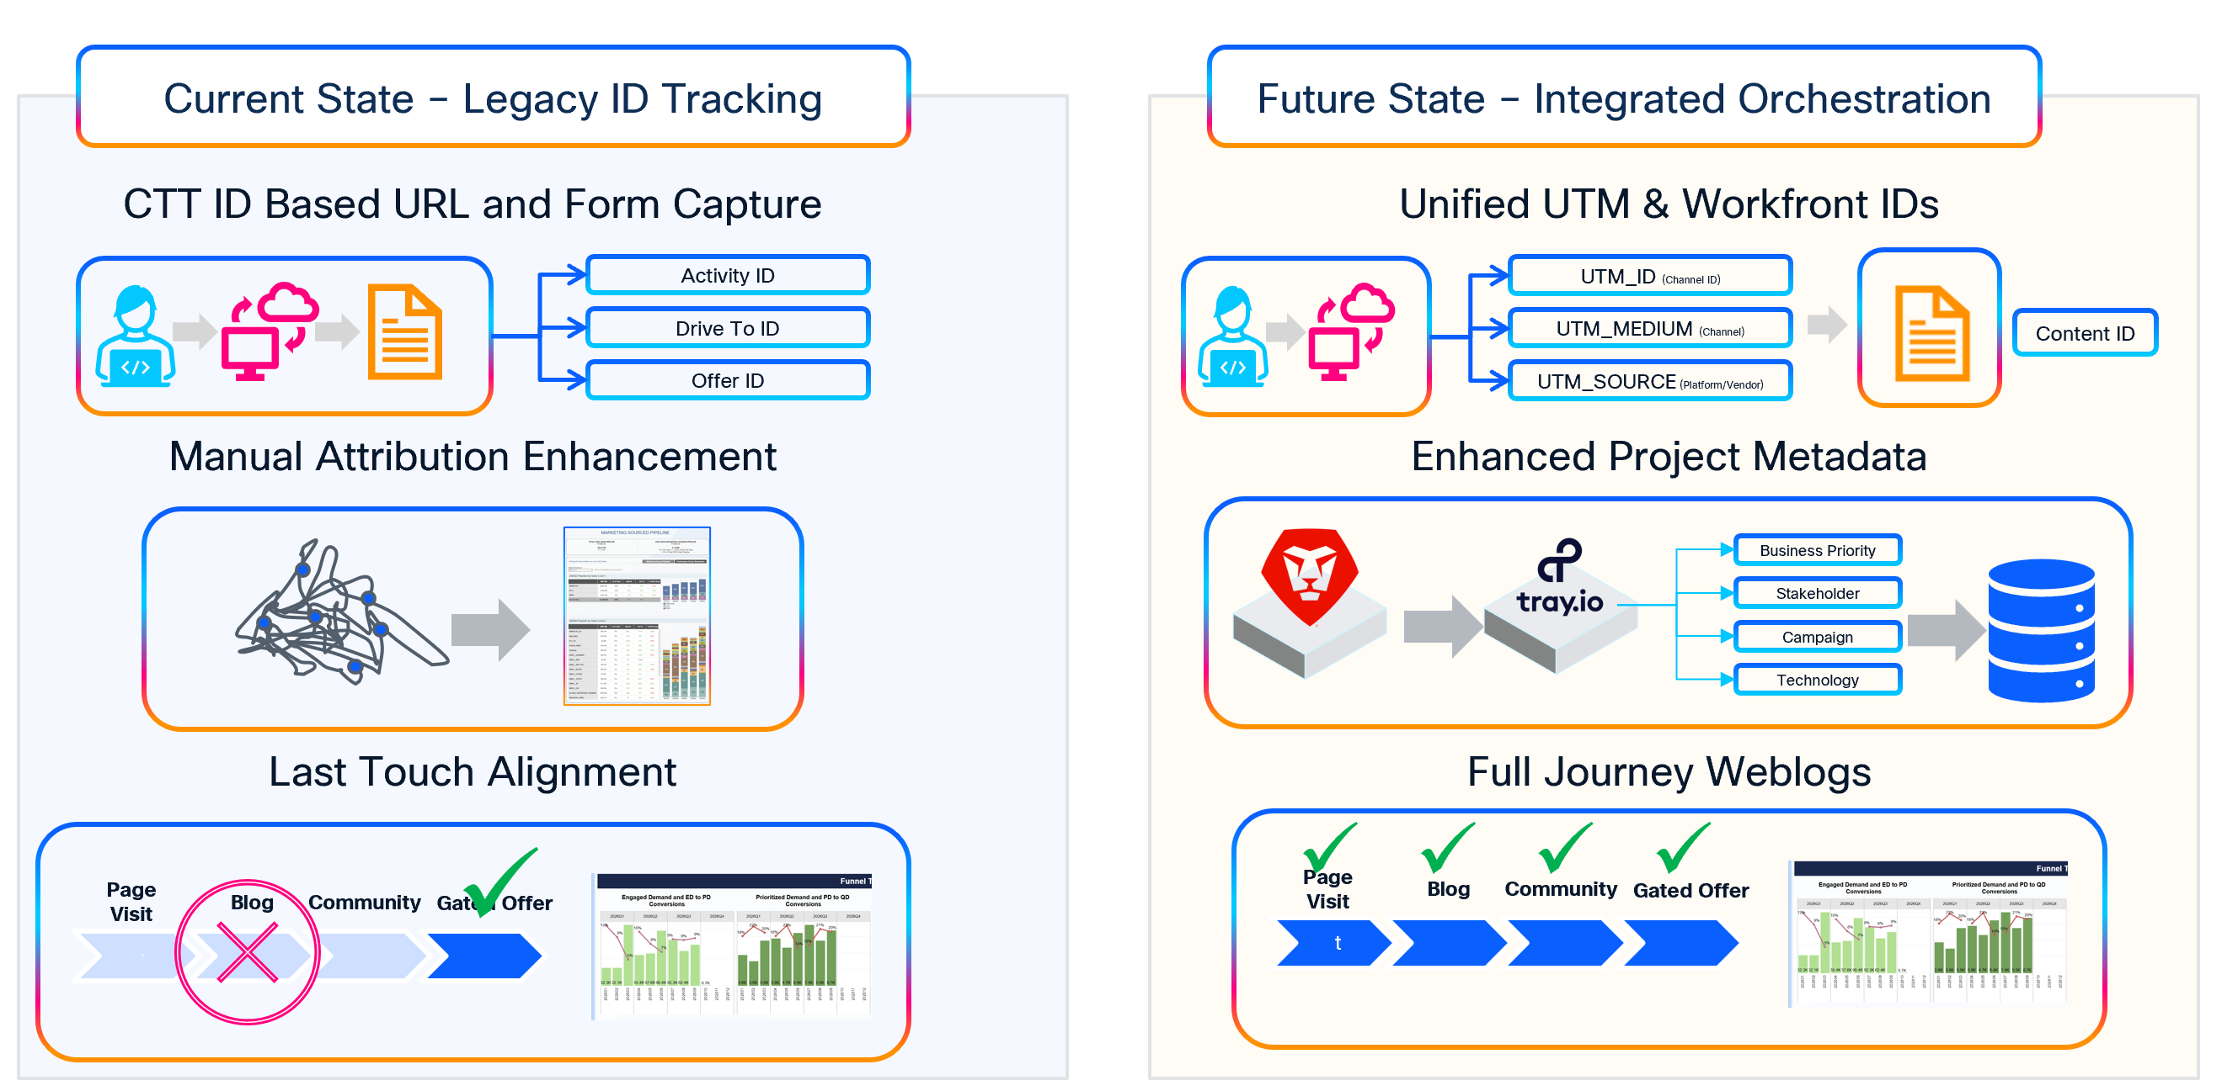

Phase 2 – Process Flow
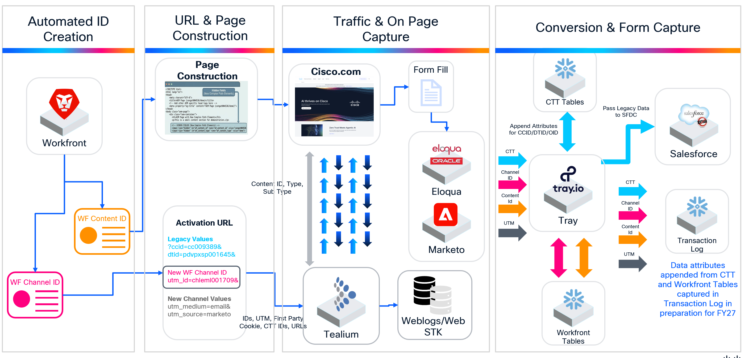

- Stakeholder Requirements

Stakeholders
Stakeholder | Code | Description
Martech | MAR | Requirements for Venkat’s Team
Demand System & Data | DSD | Requirements for Chris’sTeam
Intake | INT | Requirements for Christy’s Team
Connected Strategy & Intelligence | CSI | Requirements for Jessica’s Team

Intake Team

INT001: As a Marketing Campaign Manager, I want Workfront to automatically generate unique Channel and Content IDs for every activation, so that every project is born with a "Universal Key" for downstream tracking without manual intervention.

Field | Value
Use Case ID: | INT001
Primary Actor: | Marketing Campaign Manager / Workfront System
Goal: | Automatically generate and assign unique IDs to a campaign at the moment of creation.
Pre-Condition: | 1. Workfront is configured with the logic for the Channel/Content ID naming convention.
Trigger: | A Marketing Campaign Manager submits a new project intake form or "activates" a project in Workfront.
Main Success Path: | 1. Workfront captures project metadata (Stakeholder Unit, Year, Region, Business Priority etc).  2. The Workfront logic engine generates a Channel ID (representing the tactic, e.g., Email) and a Content ID (representing the asset, e.g., Whitepaper).  3. The system checks that the IDs are unique and do not conflict with existing records.  4. The IDs are written to the Workfront Project Object and locked to prevent manual editing.  5. Channel IDs are ready to be pulled by the Publishing team and the Channel ID added to the URL Generator as the UTM_ID value.
Post Condition: | The project is aligned with its tracking identifiers, ensuring 1:1 data alignment from Workfront to downstream systems

INT002: As a Digital Marketer, I want Workfront to automatically append the Workfront Channel ID to the UTM_ID parameter for all digital URLs , so that we can hard-link web conversions directly to specific marketing initiatives.

Field | Value
Use Case ID: | INT002
Primary Actor: | Digital Marketer / Content Publisher
Goal: | Automatically embed the Workfront Channel ID into the URL structure to ensure 1:1 attribution.
Pre-Condition: | 1. The Workfront Channel ID has been auto-generated  2. The URL generation logic/tool is integrated with Workfront.
Trigger: | The Digital Marketer requests a Channel Project within Workfront to create tracking links for a campaign tactic (e.g., a LinkedIn ad or a Display banner).
Main Success Path: | 1. The system pulls the unique Channel ID associated with the specific Workfront task/project.  2. The logic assigns the Channel ID to the utm_id parameter.  3. The tool generates the full URL, e.g., <destination>ccid=cc009389&dtid=pdvpxsp001645&utm_id=chleml000001&utm_medium=email&utm_source=marketo  4. The marketer uses this URL in the digital activation.  5. A user clicks the link; the utm_id is captured by the form and passed downstream
Post Condition: | Successful capture of the Driving marketing Initiative to be used in attribution modelling

INT003: As an Intake Team Member, I want to provide the standardized Content ID to the Publishing Team during the project hand-off, so that they can embed the ID on the destination web page, ensuring all form conversions are accurately linked to the specific content asset for granular performance tracking

Field | Value
Use Case ID: | INT003
Primary Actor: | Intake Team / Project Manager
Goal: | Successfully communicate and implement the Content ID on a live web asset.
Pre-Condition: | 1. The Content ID has been generated (via Workfront).  2. The web project has moved from the "Intake" status to "In-Progress/Publishing."
Trigger: | The Intake team completes the campaign brief and assigns the publishing task.
Main Success Path: | 1. The Intake team includes the Content_ID in the Workfront task or hand-off document.  2. The Publishing Team receives the ID and adds it to the page's metadata  3. Tealium detects this ID on page load.
Post Condition: | The content asset is can be aligned to Workfront Projects for all owned pages

MarTech Team

MAR001: As an Analytics Lead, I want to capture the Workfront Content ID from every AEM-generated page that our customer touches on his journey , so that we can accurately attribute engagement to specific content assets in our attribution reporting.

Field | Value
Use Case ID: | MAR001
Primary Actor: | Analytics Lead / Tealium Tag Manager
Goal: | Capture the specific Content ID of each page being viewed and capture it in Weblogs/WebSTK
Pre-Condition: | 1. The Publishing Team has embedded the Workfront Content ID into the AEM page metadata.  2. Tealium/Data Layer is configured to "scrape" this specific metadata field on page load.
Trigger: | A prospect visits an AEM-hosted web page or resource (e.g., a whitepaper landing page or a deep-dive product page).
Main Success Path: | 1. The user lands on the AEM page.  2. The Tealium Data Layer identifies the content_id (e.g., conweb012345) embedded in the page.  3. Tealium stores this ID in the user's browser session.
Post Condition: | The Analytics team can now run a models showing not just which ad brought the user in, but exactly which pieces of content they viewed

MAR002: As a Web Developer, I want the web layer to dynamically write the touched Content ID into the form submission record, so that the lead record in Marketo or Eloqua is stamped with the specific asset that triggered the conversion

Field | Value
Use Case ID: | MAR002
Primary Actor: | Tealium iQ / Web Developer
Goal: | Inject the "Last-Touch" Content ID into the form's payload at the moment of submission.
Pre-Condition: | 1. The content_id has been successfully captured and persisted in the Tealium Data Layer  2. The Marketo/Eloqua form has been updated to consume the Content ID
Trigger: | A user clicks the "Submit" button on a lead generation form.
Main Success Path: | 1. The system must ensure the Content ID is captured and submitted alongside the lead's form data  2. Tealium detects the most recent content_id  3. Content ID is written to the hidden field content_asset_id and consumed by Eloqua and Marketo
Post Condition: | The Marketo/Eloqua lead activity log shows the content_asset_id field populated with the correct Workfront ID.

MAR003: As a Global Strategist, I want to investigate how to capture strategic data elements from web pages outside of our direct control , so that we can maintain a holistic view of the customer journey across the entire digital ecosystem in furture releases.

Field | Value
Use Case ID: | MAR003
Primary Actor: | MarTech Engineering Team
Goal: | Conduct technical discovery and provide a recommendation for capturing 1st-party data on 3rd-party or partner-hosted domains.
Pre-Condition: | 1. Identification of high-value "off-platform" touchpoints (e.g., partner portals, co-branded sites, social aggregators).  2. Access to current Tealium/WebSDK deployment documentation.
Trigger: | The Global Strategist requests a gap analysis for "Off-Platform" tracking to support the Phase 2 roadmap.
Main Success Path: | 1. MarTech audits all digital touchpoints not hosted on primary AEM servers.  2. MarTech evaluates data capture methods  3. MarTech develops a prioritized list of technical solutions to bridge the data gap.  4. MarTech presents a "Future State Architecture" to the Global Strategist for Unified Intelligence Framework Planning
Post Condition: | A formal Technical Recommendation document is produced, outlining how to ingest external engagement data

MAR004: As a Marketing Operations Manager, I want identical custom fields and schema elements—specifically for the Workfront Channel ID (passed via utm_id) and the Content ID—provisioned across both Marketo and Eloqua, so that we have a consistent ingestion point for the "Universal Key" and behavioral metadata globally

Field | Value
Use Case ID: | MAR004
Primary Actor: | Martech Engineering Team
Goal: | Provision mirrored fields in both MAPs to capture the two-part Universal Key.
Pre-Condition: | 1. Workfront ID conventions for Channel and Content are finalized.
Trigger: | The requirement to sync enriched lead data from both systems into a single Snowflake reporting model.
Main Success Path: | 1. Create a field to capture the utm_id (which will hold the Workfront Channel ID).  2. Create the content_asset_id field to capture the Content ID from the web layer.  3. Implement these identical fields in Marketo and Eloqua  4. Ensure both systems are configured to pass these specific values to the Tray.io orchestration layer.
Post Condition: | Lead records from both systems arrive at the Transaction Log with identical headers, allowing for immediate join-logic with Workfront metadata.

MAR005: As a Marketing Manager, I want to provision an identical set of custom fields for legacy tracking tags (ccid, dtid, oid) within both Marketo and Eloqua, so that we can consistently align our reporting models in Snowflake and Salesforce regardless of which source marketing system is utilized for a specific activity.

Field | Value
Use Case ID: | MAR005
Primary Actor: | Marketing Operations / CRM Admin
Goal: | Create a mirrored field architecture for legacy identifiers across all Marketing Automation Platforms (MAPs).
Pre-Condition: | 1. Confirmation of legacy parameter names currently used in digital URLs (ccid, dtid, oid).
Trigger: | The need to migrate or run parallel reporting for legacy campaigns alongside the new Workfront-led structure.
Main Success Path: | 1. Confirm the data type (typically String/Text) and length requirements for legacy IDs.  2. ingest legacy tracking parameters  3. Ensure the names are identical in both systems to prevent mapping errors in Tray.io.
Post Condition: | Analytics can query a single column in Snowflake to retrieve legacy data, regardless of which system (Marketo or Eloqua) generated the lead.

DSD Team
DSD001: As an Data Analyst, I want the orchestration tool (Tray.io) to differentiate between Legacy IDs and Workfront IDs based on the incoming parameter format, so that it can query the correct source of truth (CTT Tool vs. Workfront/MOPS Database) to pull the predefined data elements required for lead enrichment.

Field | Value
Use Case ID: | DSD001DSD001
Primary Actor: | Tray.io / Integration Developer
Goal: | Route the enrichment lookup to the correct database based on ID type.
Pre-Condition: | 1. Tray.io has authenticated connections to both the CTT Tool and the Workfront/MOPS metadata repository. 2. A naming convention exists to distinguish IDs (e.g., CCID is numeric, Workfront ID is alphanumeric).
Trigger: | Tray.io receives a lead payload containing an identifier in the utm_id or ccid field.
Main Success Path: | 1. Tray inspects the ID string pattern.  2. The system must identify the ID format and retrieve the corresponding metadata from the appropriate source of truth.  3. Tray pulls the predefined elements (Program Name, Description, Persona, etc.).  4. Tray passed the CTT metadata into the lead object of SFDC  5. Tray publishes the enriched record to the Transaction Log
Post Condition: | Leads are enriched with the correct "source of truth" metadata regardless of whether the campaign was built in the legacy or new system.

DSD002: As a Project Stakeholder, I want the orchestration tool to store all Phase 2 metadata within its published transaction logs rather than pushing to SFDC, so that we can validate the end-to-end data flow and maintain a record of customer intent without incurring unnecessary IT development costs during the current CRM resource freeze

Field | Value
Use Case ID: | DSD002
Primary Actor: | Tray.io / Data Engineer
Goal: | Capture the complete enriched payload in the persistent Transaction Log.
Pre-Condition: | 1. The Transaction Log schema has been expanded to include legacy and MOPS-specific columns.  2. Tray.io has successfully performed the ID differentiation lookup
Trigger: | Tray.io completes the enrichment of a lead payload from Marketo or Eloqua.
Main Success Path: | 1. Data Assembly: Tray gathers all captured fields (from the form) and enriched fields (from CTT/Workfront).  2. Logging Operation: Before the SFDC "Gatekeeper" filters are applied, Tray writes a row to the Transaction Log.  3. Attribute Mapping: Tray maps the "New" and "Legacy" fields into their respective columns.  4. Timestamping: Tray appends a precise Processing_Timestamp for audit purposes.
Post Condition: | Even if a lead is filtered out of the SFDC sync (e.g., non-VDC record), the full marketing touchpoint data is preserved in the logs for top-of-funnel analysis.

DSD003: As a QA Engineer, I want a synchronized, high-fidelity staging ecosystem across all platforms , so that we can validate complex "Dual-Ingestion" logic without risking live lead data or production stability.

Field | Value
Use Case ID: | DSD003
Primary Actor: | QA Engineer / MarTech Architect
Goal: | Create a safe "Mirror World" for end-to-end testing of the new tracking architecture.
Pre-Condition: | 1. Sandbox environments for Marketo, Eloqua, and SFDC are provisioned.  2. A "QA Instance" of the Tray.io workflow is cloned from the production blueprint.
Trigger: | Deployment of new code or configuration changes (e.g., new utm_id logic) that requires verification before "Go-Live."
Main Success Path: | 1. Ensure the staging versions of AEM and Tealium are passing the same metadata headers as the production specs.  2. QA generates test leads with both Legacy IDs (ccid) and New IDs (utm_id).  3. Tray.io (Staging) correctly identifies the ID type and queries the appropriate source (CTT vs. Workfront Sandboxes).  4. Verify that data lands in the mirrored custom fields in the MAP Sandboxes.  5. Intentionally submit "junk" IDs to ensure the Error Handling logic routes them correctly.
Post Condition: | A "BAT Pass" is agreed, confirming the logic is stable and ready for production deployment.

CSI Team
CSI001: As a CSI Team Member, I want a documented Hybrid Reporting Mapping and Legacy Translation document , so that I can build technical "Data Bridges" in Snowflake that maintain attribution history during the transition to FY27 standards.

Field | Value
Use Case ID: | CSI001
Primary Actor: | CSI Team Member/DOPT
Goal: | Establish a unified translation layer between legacy "Vehicle-based" tracking and the new "Workfront-ID" standards.
Pre-Condition: | 1. Access to historical CCID/DTID/OID data from the CTT Tool.  2. Finalized Workfront Metadata Schema (Program, Asset, Persona).
Trigger: | The requirement to generate a "Cross-Standard" performance report that compares legacy results against new Workfront-led activations
Main Success Path: | 1. Document all legacy data capture methods by vehicle (e.g., Email vs. Paid Search vs. Event)  2. Map the new Workfront IDs (utm_id / Channel ID and Content ID) to their specific data elements within Workfront (  3. Create the "Old-to-New" alignment table that dictates how a legacy Email CCID should be categorized under the new FY27 Taxonomy.
Post Condition: | A permanent translation repository exists, allowing for seamless Year-over-Year (YoY) analysis without manual spreadsheet manipulation.

- Glossary of Terms

Glossary
<An alphabetical list of terms in a particular domain of knowledge with the definitions for those terms>

Acronym | Description
SLA | Service Level Agreement
KPI | Key Performance Indicators
UTM | Urchin Tracking Module
VDC | Virtual Demand Centre
SIIA | Strategy, Investments, Insights and Analytics
AEM | Adobe Experience Manager used to build and manage websites
Tealium | Customer data orchestration platform to collect, orchestrate and activate customer data
Snowflake | Data warehouse
Tray.io | Integration platform that allows us to connect software applications

- Approvals and Sign-Off

Document Reviewers
Name | Role | Reviewer | Approver | Date
Name | Position in the Project |  |  | Date agreed
Kim Braithwaite | BCO Eloqua
Konstantin Zobov | BCO Tealium
Christy Parker | BCO Workfront
Chris Shatara | DSD
Venkat Krishnamurthy | Martech
Jessica Widener | CSI
Sudhakar Adusumilly | CETO

